- V-n diagram
In this appendix the generation of the V-n diagram will be treated. With this diagram the maximum load factor, , on the aircraft can be determined. This maximum load factor is used in the weight calculations of the wing and other components. To give an idea of the values of the maximum limit loads some values are presented in Table A.1:

Table A.1: Characteristic values of maximum load factors of various aircraft types
Aircraft Type | Load factor
General Aviation (normal) | -1.25 |  | n |  | 3.1
General Aviation (utility) | -1.8 |  | n |  | 4.4
General Aviation (acrobatic) | -3.0 |  | n |  | 6.0
Homebuilt | -2 |  | n |  | 5
Commercial Transport | -1.5 |  | n |  | 3.5
Fighter | -4.5 |  | n |  | 7.75

Two cases must be evaluated; the load factor during maneuvers and during gust. The largest one determines the limit load factor.

- Maneuver loading

The loading during maneuvers are specified in the Airworthiness certification specifications. For different flight conditions different requirements are set. A typical maneuver loading diagram is given:

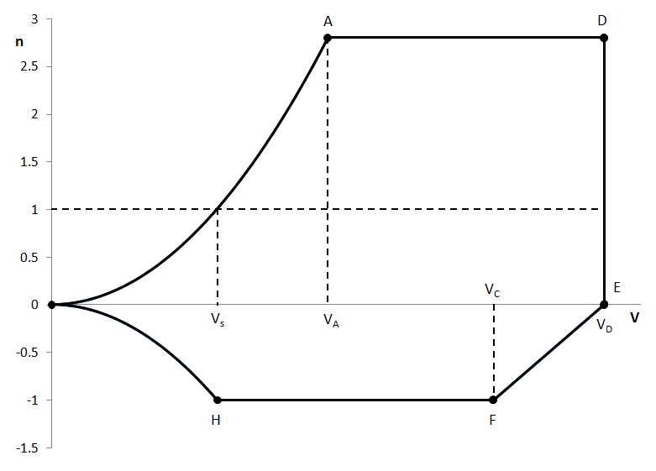
Figure A.1: Maneuver load diagram

The first curve from 0-A represents by the maximum normal component load due to a high angle of attack and thus maximum positive lift. This curve is defined by equation A.1:

 | 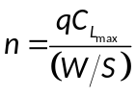 | ( | A.1 | )

The stall speed is visualized in Figure A.1 there where curve 0-A crosses the line. The limit of the curve 0-A is imposed by the value of the maximum limit load factor of line A-D. This value is specified in CS-23 and CS-25 and is different for different aircraft categories. In Table A.2 the values are specified.

Table A.2: Maximum positive limit load factor for different aircraft categories
CS | Aircraft type |  | 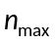
CS-23 | Normal + Commuter |  | 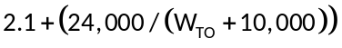
CS-23 | Utility
CS-23 | Aerobatic |  | 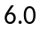
CS-25 | Transport | 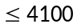[lbs] | 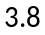
CS-25 | Transport | 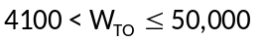[lbs]
CS-25 | Transport | 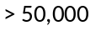[lbs] | 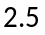

The maximum positive load factor of transport aircraft under the CS-25 airworthiness certifications is also visualized in Figure A.2:

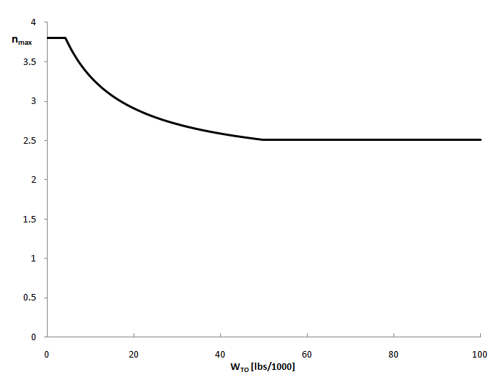
Figure A.2: Maximum positive load factor for transport aircraft subject to CS-25

The speed corresponding with point D is the dive speed, this speed is also defined in the certification specifications. The value of 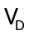 must comply with the following requirement: 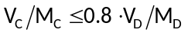. In general M_{D} is 0.05M higher than M_{c.} The line D-E is simply a vertical connecting the two points. The line E-F is a linear and connects point E with point F located at the cruise speed. The load factor of point F is given by the maximum negative limit load which is also given by the certification specifications (see Table A.3).

Table A.3: Maximum negative limit load factor for different aircraft categories
CS | Aircraft type | 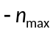
CS-23 | Normal + Commuter + Utility | 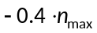
CS-23 | Aerobatic | 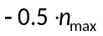
CS-25 | Transport

The curve H-F is thus defined by the maximum negative limit load. The curve H-0 is given by the negative of equation A.1. Point H is thus the point at which the curve H-0 and the line F-H cross.

The maximum and minimum limit load factors are easily found from this part of the load diagram. It are the constant values of the lines A-D and F-H respectively.

- Gust loading

The second part of a V-n diagram is given by the load factor during a gust. An example of a gust load diagram is given in Figure A.3:

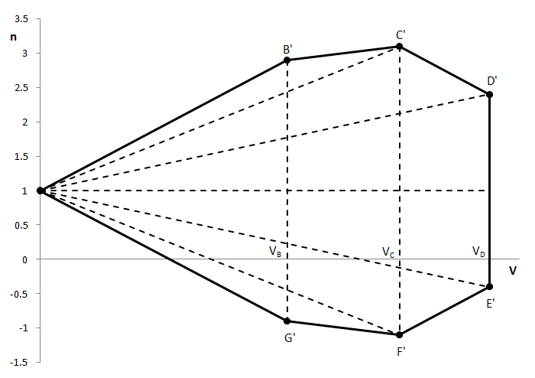
Figure A.3: Gust load diagram

The gust at 3 velocities must be evaluated: the speed at which highest lift and maximum angle of attack occurs (V_{B}), the cruise speed (V_{C}) and the dive speed (V_{D}). The corresponding gust speeds vary with the condition and with altitude. The maximum load factor due to gust is then given by equation A.2. The value of 1 represents the mean load factor. It is assumed the aircraft has this load factor of 1 before the gust occurs.

 | 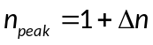 | ( | A.2 | )

The value of 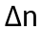 is derived with the following model (Figure A.4):

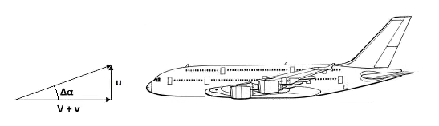
Figure A.4: Model for gust load effect on aircraft

An increment in angle of attack is caused by the gust speed components u and v. This increment in angle of attack due is defined as (equation A.3):

 | 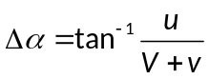 | ( | A.3 | )

With the assumption the gust speed is low with respect to the flight speed, the quotient 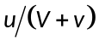 is approximately 1, and thus the arctangent of can be assumed to be . Furthermore can be assumed that V+v≈V. With these approximations equation A.3 can be simplified to equation A.4:

 | 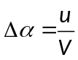 | ( | A.4 | )

The incremental lift produced by the change in angle of attack is given in equation A.5:

 | 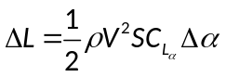 | ( | A.5 | )

When equation A.4 is substituted in equation A.5, equation A.6 is obtained:

 | 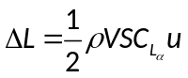 | ( | A.6 | )

With equation A.6 the incremental load factor is obtained by equation the lift to the weight times the load factor (equation A.7):

 | 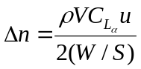 | ( | A.7 | )

To be able to calculate this incremental load factor the normal component of the gust velocity u is required. This value can be calculated using statistical gust velocities () and the so-called load alleviation factor K (equation A.8).

 | 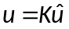 | ( | A.8 | )

The definition of K changes according to the aircraft speed regime, as shown in equation A.9 or A.10:

 | 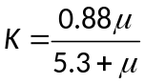 (subsonic) |  | ( | A.9 | )
 | 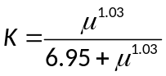 (supersonic) | ( | A.10 |  | )

The parameter is an equivalent mass ratio and is defined in equation A.11:

 | 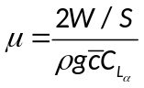 | ( | A.11 | )

To obtain the right values for the coefficient K, must be calculated using British units (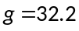 [f/s²]). The values for û are based on statistics. They change with altitude and flight condition as presented in Table A.4 and Figure A.5:

Table A.4: Gust velocities for different conditions
Flight condition | Altitude range [f] | û [f/s]
High angle of attack | 0-20,000 | 66
High angle of attack | 50,000 | 38
Level flight | 0-20,000 | 50
Level flight | 50,000 | 25
Dive condition | 0-20,000 | 25
Dive condition | 50,000 | 12.5

Table A.4 is visualized in Figure A.5:

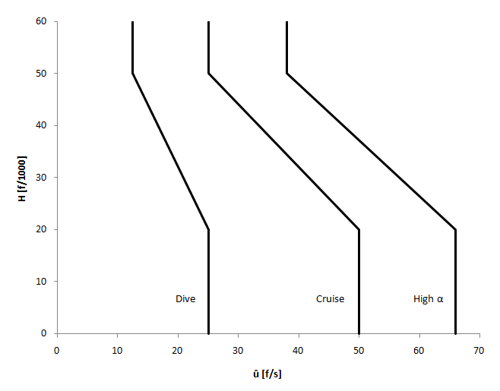
Figure A.5: Variation of gust velocity û with altitude and flight condition

Using this method the maximum load factor can be calculated for a certain condition. Knowing the cruise and dive speed, points C’ and D’ can be determined. Points E’ and F’ are calculated with the same flight speed, but with a negative gust velocity. The value of is thus of opposite sign with respect to points C’ and D’. To be able to determine points B’ and G’ the same way as the other, the value of VB (the design speed for maximum gust intensity) must be specified. There are some guidelines for this value; VB may not be lower than the speed at which the line representing the incremental load factor and the curve of maximum positive lift cross, or the value of 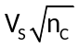 whichever one is lower. The curve of maximum positive lift is defined in Figure A.1 as curve 0-A. The value of V_{S} is known or can be found in Figure A.1 as well. The value of 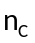 is the maximum load factor due to gust at cruise speed which is calculated above. When the points 1, B’, C’, D’, E’, F’ and G’ are connected with linear lines the total diagram is complete as in Figure A.3.

- Maximum load factor

The maximum and minimum load factors can be finally derived by superimposing the maneuver and gust diagrams from section A.1 and A.2 and picking the highest and lowest (most negative) load factors.

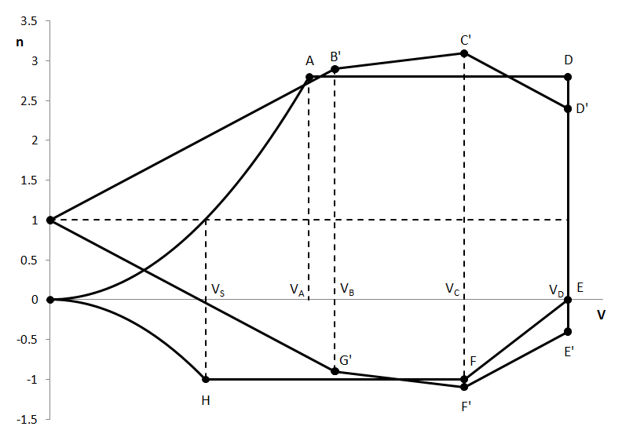
Figure A.6: Combined load diagram

In particular case shown in Figure A.6 one can see that the points C’ and F’ are the maximum and minimum load factors, with a value of respectively 3.1 and -1.1. To obtain the load factors for the further design () the found values must be multiplied with the standard safety factor 1.5 (equation A.12).

 |  | ( | A.12 | )

In the above case, the design load factors obtained are 4.65 and -1.65.

The example in Figure A.6 is representative of possible case for transport aircraft where gust loads are dominant. However, this is not always the case, as the incremental load factor due to gust depends on the flight conditions chosen in the mission of the aircraft, the wing loading and the effectiveness of the wing (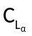). Equation A.7 shows that aircraft with higher wing loading are less sensitive to gust, whilst higher values make the aircraft more sensible to gust. This can be easily explained by the fact that a higher or higher wing surface S (for a given aircraft weight) yield a higher 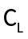 with a certain angle of attack, and thus a larger increment of lift.

Given the sensitivity of the maximum load factors with wing loading and altitude (via the air density), the CS require the generation of V-n diagrams:
(1) At each critical altitude within the range of altitudes selected by the applicant;
(2) At each weight from the design minimum weight to the design maximum weight appropriate to each particular flight load condition; and
(3) For each required altitude and weight, for any practicable distribution of disposable load within the operating limitations recorded in the Aeroplane Flight Manual.

Disclaimer
The information provided above is a simple (and incomplete) summary of the applying CS. Refer to CS23-321/341 and CS25-321/341 for details.

